CloudWatch and SNS

* Create a dashboard with few metrics using cloudWatch and share with others

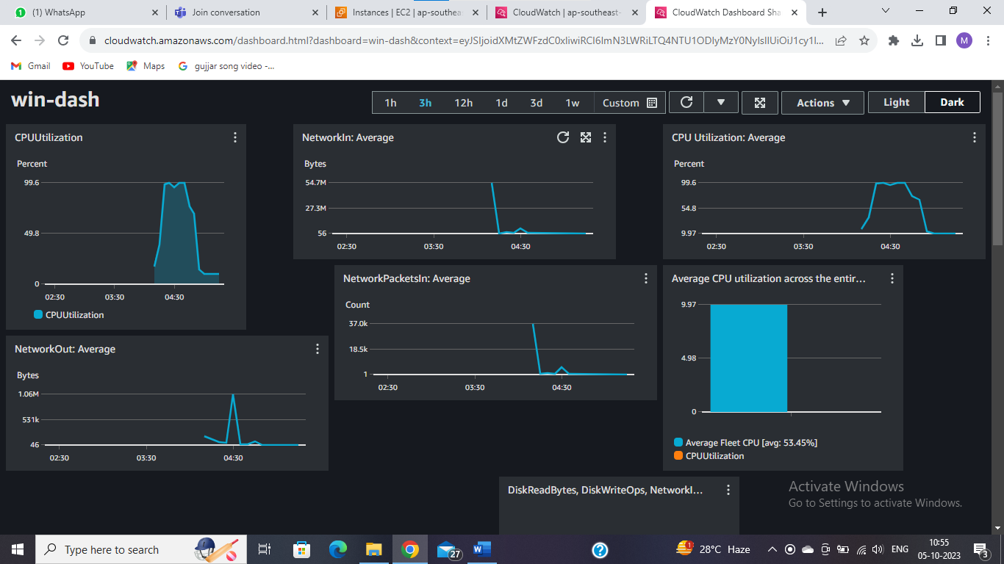

* Create an alarm in CloudWatch for CPU utilization metrics for an ec2 instance.

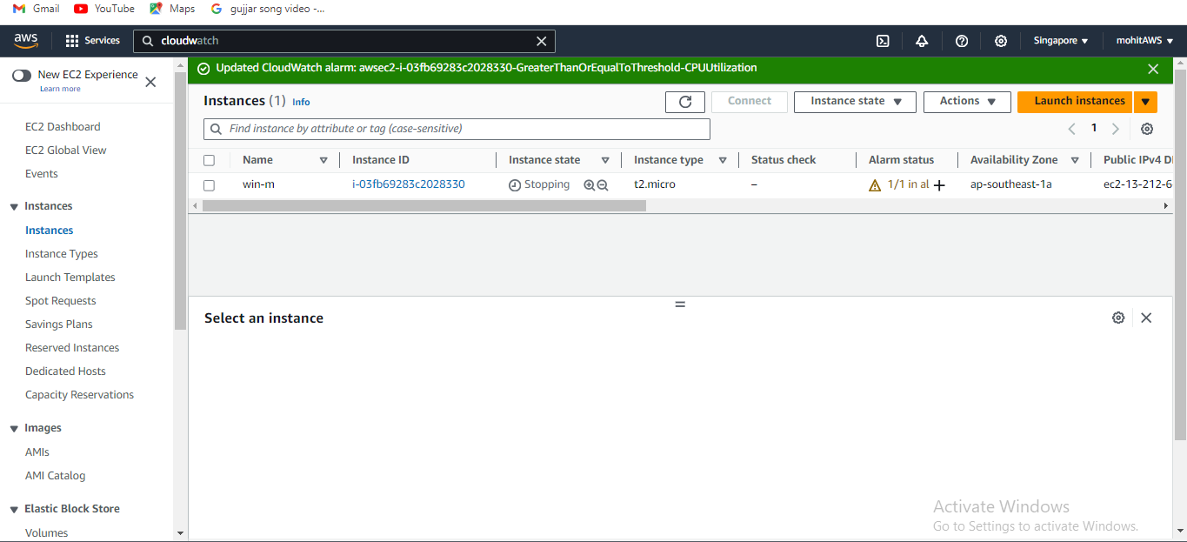

* Create a topic and a subscription in SNS with Email protocol
* Implement CloudWatch with Agent and System Manager